CHAPTER 17
Locomotion and Movement

Movement is one of the significant features of living beings. Animals and plants exhibit a wide range of movements. The streaming of protoplasm in unicellular organisms like Amoeba is a simple form of movement; the movement of cilia, flagella and tentacles is shown by many organisms; and human beings can move their limbs, jaws, eyelids, tongue, etc.
• Locomotion - some movements result in a change of place or location. Such voluntary movements are called locomotion. Walking, running, climbing, flying and swimming are all forms of locomotory movements.
• Locomotory structures need not be different from those affecting other types of movements. For example, in Paramoecium, cilia help in the movement of food through the cytopharynx and in locomotion as well; Hydra can use its tentacles for capturing prey and for locomotion; and we use our limbs for changes in body posture and for locomotion.
These observations suggest that movements and locomotion cannot be studied separately. The two may be linked by stating that all locomotions are movements but all movements are not locomotions.
• Methods of locomotion vary with the animal's habitat and the demand of the situation. However, locomotion is generally for the search of food, shelter, mate, suitable breeding grounds, favourable climatic conditions, or to escape from enemies/predators.
17.1 | Types of Movement

Cells of the human body exhibit three main types of movements, namely, amoeboid, ciliary and muscular.
Type | Where it occurs | How it works
Amoeboid | Specialised cells like macrophages and leucocytes in blood | Effected by pseudopodia formed by the streaming of protoplasm (as in Amoeba); cytoskeletal elements like microfilaments are also involved.
Ciliary | Most internal tubular organs lined by ciliated epithelium | Coordinated cilia in the trachea help remove dust particles and foreign substances inhaled with air; the passage of ova through the female reproductive tract is also facilitated by ciliary movement.
Muscular | Limbs, jaws, tongue, etc. | Uses the contractile property of muscles; effectively used for locomotion and other movements by human beings and the majority of multicellular organisms.

[NOTE] Locomotion requires a perfect coordinated activity of the muscular, skeletal and neural systems. This chapter covers the types of muscles, their structure, the mechanism of their contraction, and the important aspects of the skeletal system.

17.2 | Muscle

Cilia and flagella are outgrowths of the cell membrane. Flagellar movement helps in the swimming of spermatozoa, the maintenance of water current in the canal system of sponges, and in the locomotion of Protists like Euglena.
• Muscle - a specialised tissue of mesodermal origin. About 40-50 per cent of the body weight of a human adult is contributed by muscles.
• Muscles have special properties: excitability, contractility, extensibility and elasticity.
Muscles have been classified using different criteria, namely location, appearance and nature of regulation of their activities. Based on their location, three types are identified: (i) Skeletal (ii) Visceral and (iii) Cardiac.
Muscle type | Location | Appearance | Regulation | Chief role
Skeletal | Closely associated with the skeletal components of the body | Striped / striated under the microscope | Under voluntary control of the nervous system (voluntary muscles) | Primarily locomotory actions and changes of body posture
Visceral | Inner walls of hollow visceral organs - alimentary canal, reproductive tract, etc. | No striation, smooth (smooth / nonstriated muscle) | Not under voluntary control (involuntary muscles) | Transport of food through the digestive tract and gametes through the genital tract
Cardiac | Muscles of the heart; many cells assemble in a branching pattern | Striated | Involuntary - the nervous system does not control them directly | Contraction of the heart

Structure of a skeletal muscle. Each organised skeletal muscle is made of a number of muscle bundles or fascicles held together by a common collagenous connective tissue layer called fascia. Each muscle bundle contains a number of muscle fibres (Figure 17.1). The bundle is also served by a blood capillary supply drawn in the cross-section.
• Sarcolemma / sarcoplasm. Each muscle fibre is lined by the plasma membrane called sarcolemma enclosing the sarcoplasm. A muscle fibre is a syncitium (source spelling) as the sarcoplasm contains many nuclei.
• The endoplasmic reticulum, i.e. the sarcoplasmic reticulum of the muscle fibres, is the store house of calcium ions (Ca⁺⁺).
• A characteristic feature of the muscle fibre is a large number of parallelly arranged filaments in the sarcoplasm called myofilaments or myofibrils.
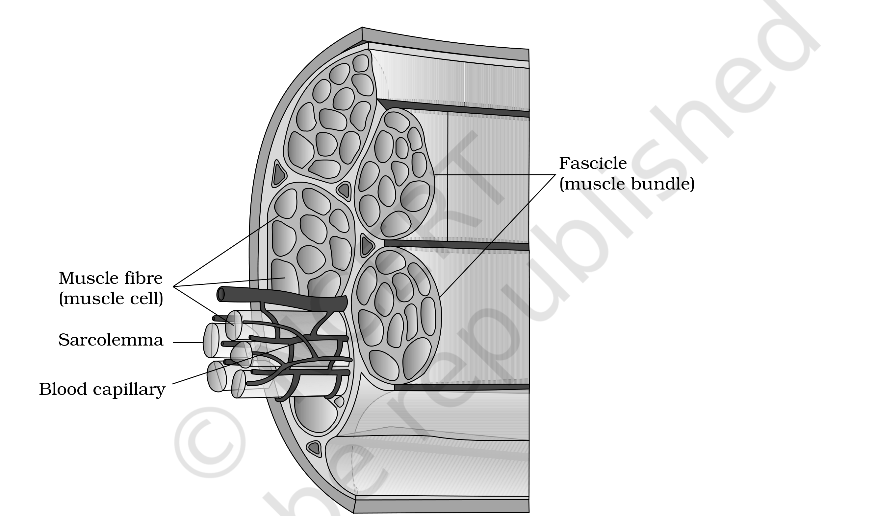
Figure 17.1 Diagrammatic cross sectional view of a muscle showing muscle bundles and muscle fibres
Banding pattern. Each myofibril has alternate dark and light bands on it. The striated appearance is due to the distribution pattern of two important proteins - Actin and Myosin.
Band / line | Also called | Contents
'I' band (light) | Isotropic band | Contains actin (thin filament)
'A' band (dark) | Anisotropic band | Contains myosin (thick filament)
'Z' line | Elastic fibre bisecting each 'I' band | Thin filaments are firmly attached to it
'M' line | Thin fibrous membrane | Holds the thick filaments together in the middle of the 'A' band
'H' zone | Central part of the 'A' band | The part of the thick filament not overlapped by thin filaments - i.e. thick filaments only

• Both proteins are arranged as rod-like structures, parallel to each other and to the longitudinal axis of the myofibrils. Actin filaments are thinner than the myosin filaments, hence they are commonly called thin and thick filaments respectively.
• The 'A' and 'I' bands are arranged alternately throughout the length of the myofibrils.
• Sarcomere - the portion of the myofibril between two successive 'Z' lines. It is the functional unit of contraction (Figure 17.2). (The muscle fibre itself is the anatomical unit of muscle, while the sarcomere is its functional unit.)
• In a resting state, the edges of the thin filaments on either side of the thick filaments partially overlap the free ends of the thick filaments, leaving the central part of the thick filaments (the 'H' zone) free.
• Each sarcomere therefore has one central 'A' band made of thick myosin filaments, and two half 'I' bands made of thin actin filaments on either side of it, marked off by 'Z' lines.
[MEMORY AID - not in NCERT] Mnemonic for what shortens: only the 'I' band and the 'H' zone shrink on contraction - the 'A' band never does.

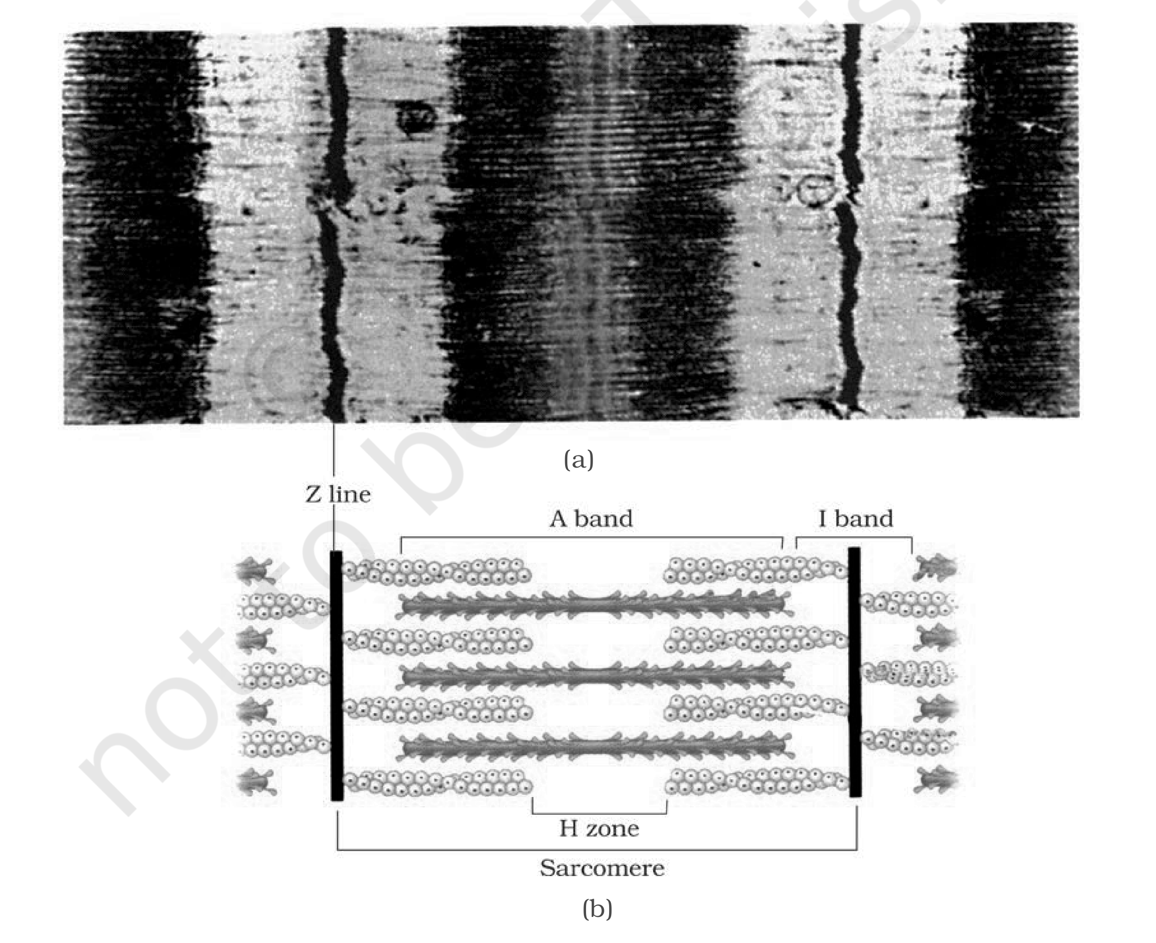
Figure 17.2 Diagrammatic representation of (a) anatomy of a muscle fibre showing a sarcomere (b) a sarcomere
17.2.1 | Structure of Contractile Proteins

Actin (thin) filament. Each actin filament is made of two 'F' (filamentous) actins helically wound to each other. Each 'F' actin is a polymer of monomeric 'G' (Globular) actins.
• Two filaments of another protein, tropomyosin, also run close to the 'F' actins throughout their length.
• A complex protein Troponin is distributed at regular intervals on the tropomyosin. In the resting state, a subunit of troponin masks the active binding sites for myosin on the actin filaments (Figure 17.3a).
Myosin (thick) filament. Each myosin filament is also a polymerised protein. Many monomeric proteins called Meromyosins (Figure 17.3b) constitute one thick filament.
Part of a meromyosin | Name | Feature
Globular head + short arm | Heavy meromyosin (HMM) | Projects outwards at regular distance and angle from the surface of the filament, forming the cross arm; the head is an active ATPase enzyme with binding sites for ATP and active sites for actin.
Tail | Light meromyosin (LMM) | The rod-like shaft of the monomer.

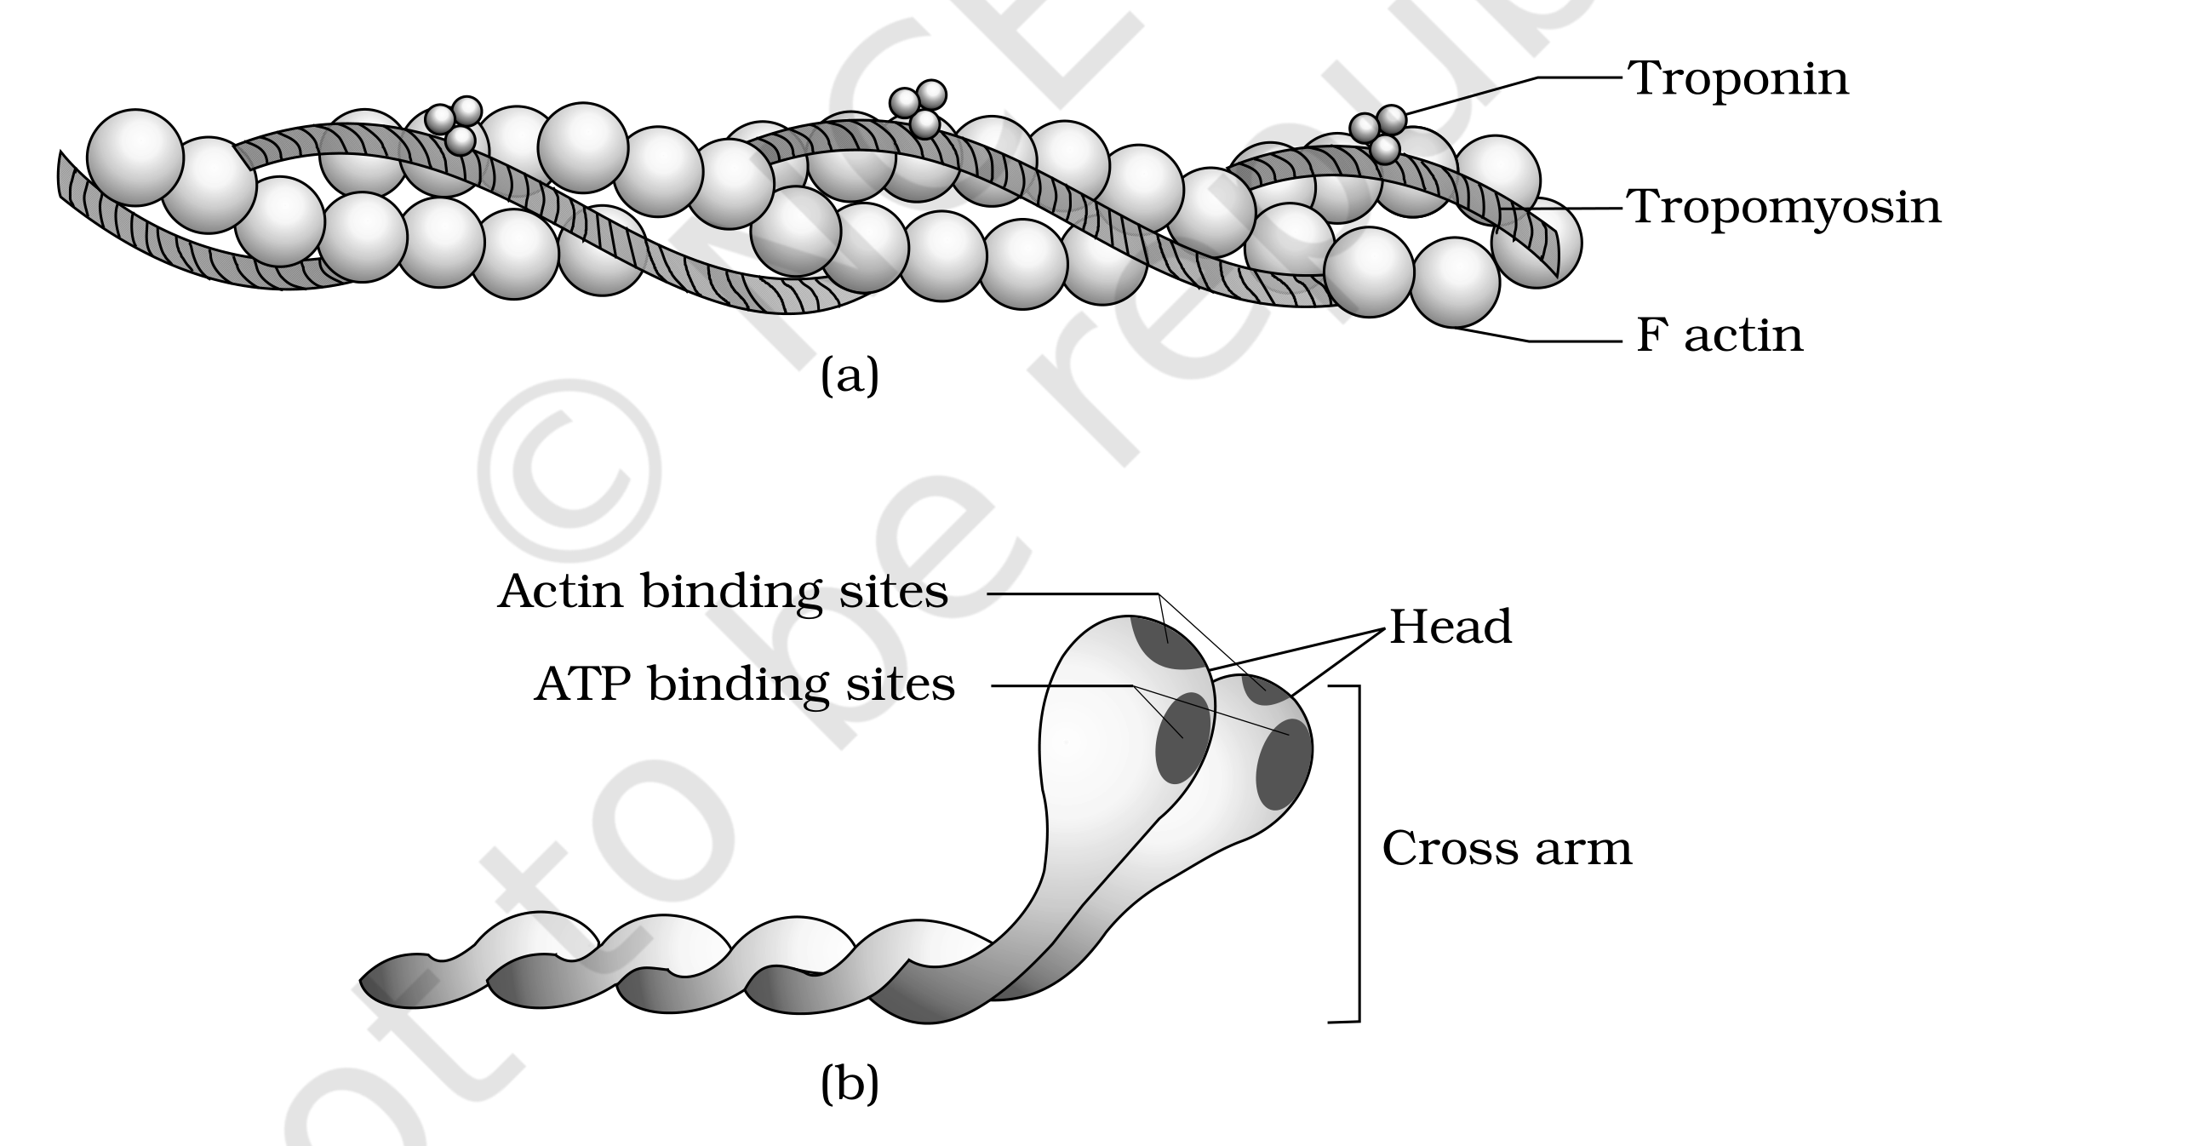
Figure 17.3 (a) An actin (thin) filament (b) Myosin monomer (Meromyosin)
17.2.2 | Mechanism of Muscle Contraction

• Sliding filament theory - the mechanism of muscle contraction is best explained by this theory, which states that contraction of a muscle fibre takes place by the sliding of the thin filaments over the thick filaments.
• Motor unit - a motor neuron along with the muscle fibres connected to it. The junction between a motor neuron and the sarcolemma of the muscle fibre is the neuromuscular junction or motor-end plate.
The contraction cycle, step by step:
1 | Contraction is initiated by a signal sent by the central nervous system (CNS) via a motor neuron.
2 | The neural signal reaching the neuromuscular junction releases a neurotransmitter (Acetyl choline), which generates an action potential in the sarcolemma.
3 | The action potential spreads through the muscle fibre and causes the release of calcium ions (Ca⁺⁺) into the sarcoplasm.
4 | The rise in Ca⁺⁺ level leads to the binding of calcium with a subunit of troponin on the actin filaments, which removes the masking of the active sites for myosin.
5 | Using energy from ATP hydrolysis, the myosin head binds to the exposed active sites on actin to form a cross bridge (Figure 17.4).
6 | The cross bridge pulls the attached actin filaments towards the centre of the 'A' band; the 'Z' lines attached to these actins are also pulled inwards, shortening the sarcomere - i.e. contraction.
7 | The myosin head, releasing the ADP and P_{i}, goes back to its relaxed state. A new ATP binds and the cross bridge is broken (Figure 17.4).
8 | The ATP is again hydrolysed by the myosin head and the cycle of cross-bridge formation and breakage repeats, causing further sliding.
9 | The process continues till the Ca⁺⁺ ions are pumped back into the sarcoplasmic cisternae, masking the actin filaments again; the 'Z' lines return to their original position - i.e. relaxation.

• During shortening (contraction), the 'I' bands get reduced, whereas the 'A' bands retain their length (Figure 17.5). The figure stages this across three states of the sarcomere: Relaxed, Contracting and Maximally Contracted.
• The reaction time of the fibres can vary in different muscles.
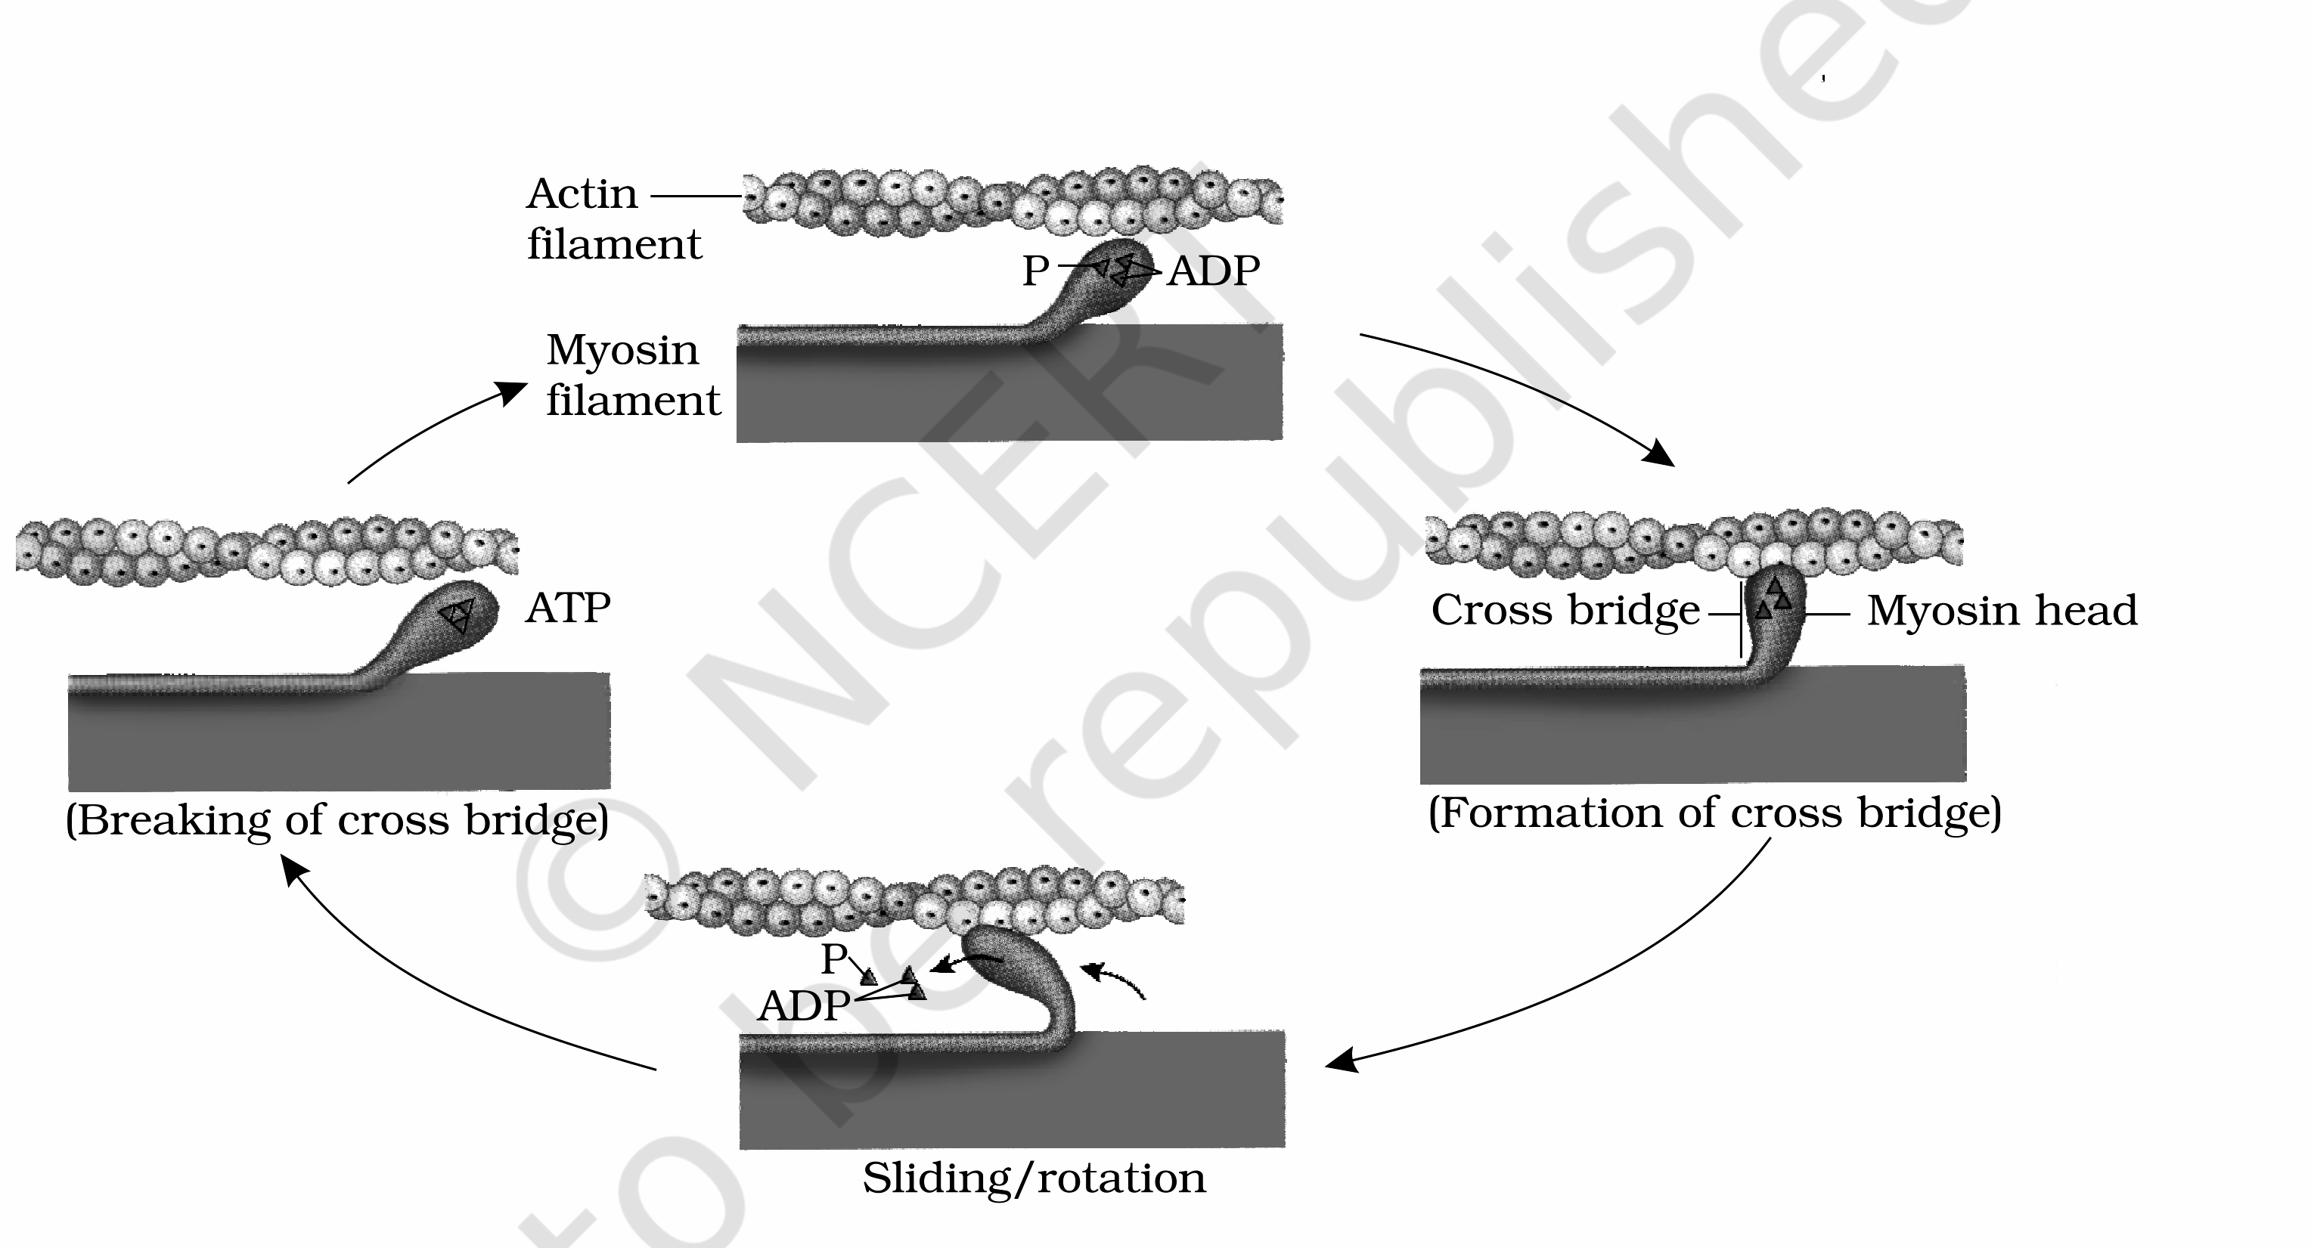
Figure 17.4 Stages in cross bridge formation, rotation of head and breaking of cross bridge
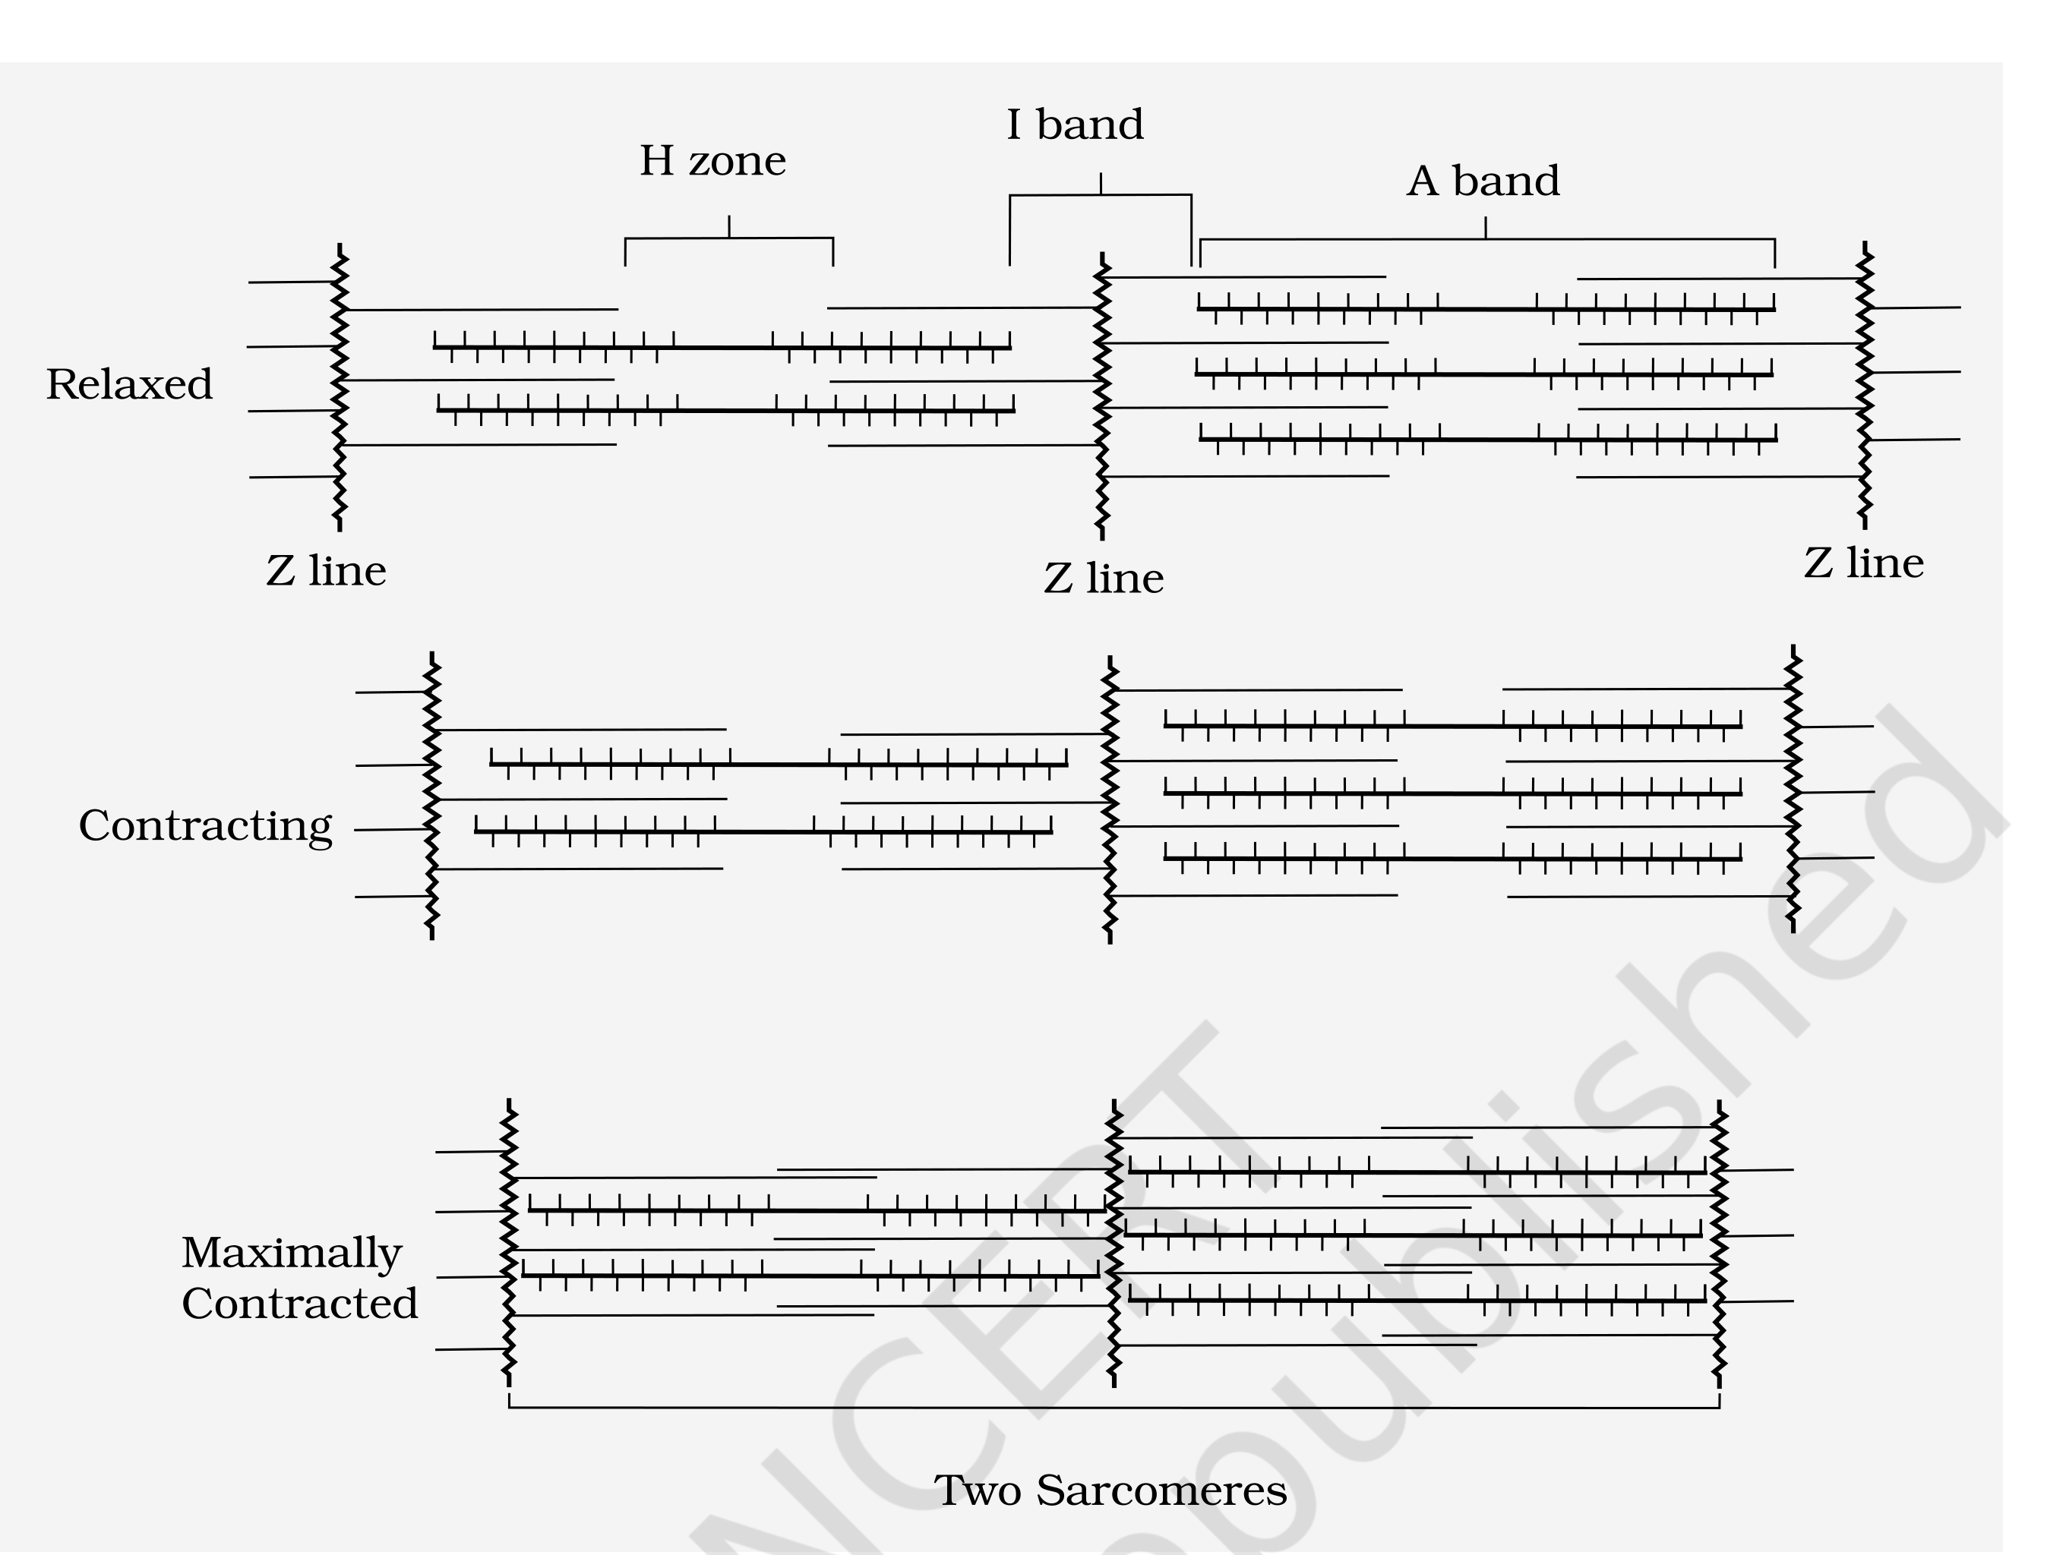
Figure 17.5 Sliding-filament theory of muscle contraction (movement of the thin filaments and the relative size of the I band and H zones)
Fatigue. Repeated activation of the muscles can lead to the accumulation of lactic acid due to the anaerobic breakdown of glycogen in them, causing fatigue.
Red vs White fibres. Muscles are classified as Red and White fibres based primarily on the amount of the red-coloured oxygen-storing pigment myoglobin.
Feature | Red fibres | White fibres
Myoglobin | High - gives a reddish appearance | Low - appear pale / whitish
Mitochondria | Plenty | Few
Sarcoplasmic reticulum | Lower | High
Energy source | Use stored O₂ for ATP - aerobic muscles | Depend on the anaerobic process for energy

17.3 | Skeletal System

The skeletal system consists of a framework of bones and a few cartilages. This system has a significant role in the movement shown by the body - imagine chewing food without jaw bones and walking around without limb bones.
• Bone and cartilage are specialised connective tissues. Bone has a very hard matrix due to calcium salts; cartilage has a slightly pliable matrix due to chondroitin salts.
• In human beings, the skeletal system is made up of 206 bones and a few cartilages, grouped into two principal divisions - the axial and the appendicular skeleton.
17.3.axial | Axial Skeleton

The axial skeleton comprises 80 bones distributed along the main axis of the body: the skull, vertebral column, sternum and ribs.
Skull (Figure 17.6). The skull is composed of two sets of bones - cranial and facial - that total 22 bones. Cranial bones are 8 in number and form the hard protective outer covering, the cranium, for the brain. The facial region is made up of 14 skeletal elements that form the front part of the skull.
• A single U-shaped bone called hyoid is present at the base of the buccal cavity.
• Each middle ear contains three tiny bones - Malleus, Incus and Stapes, collectively called Ear Ossicles.
• The skull articulates with the superior region of the vertebral column with the help of two occipital condyles (dicondylic skull).
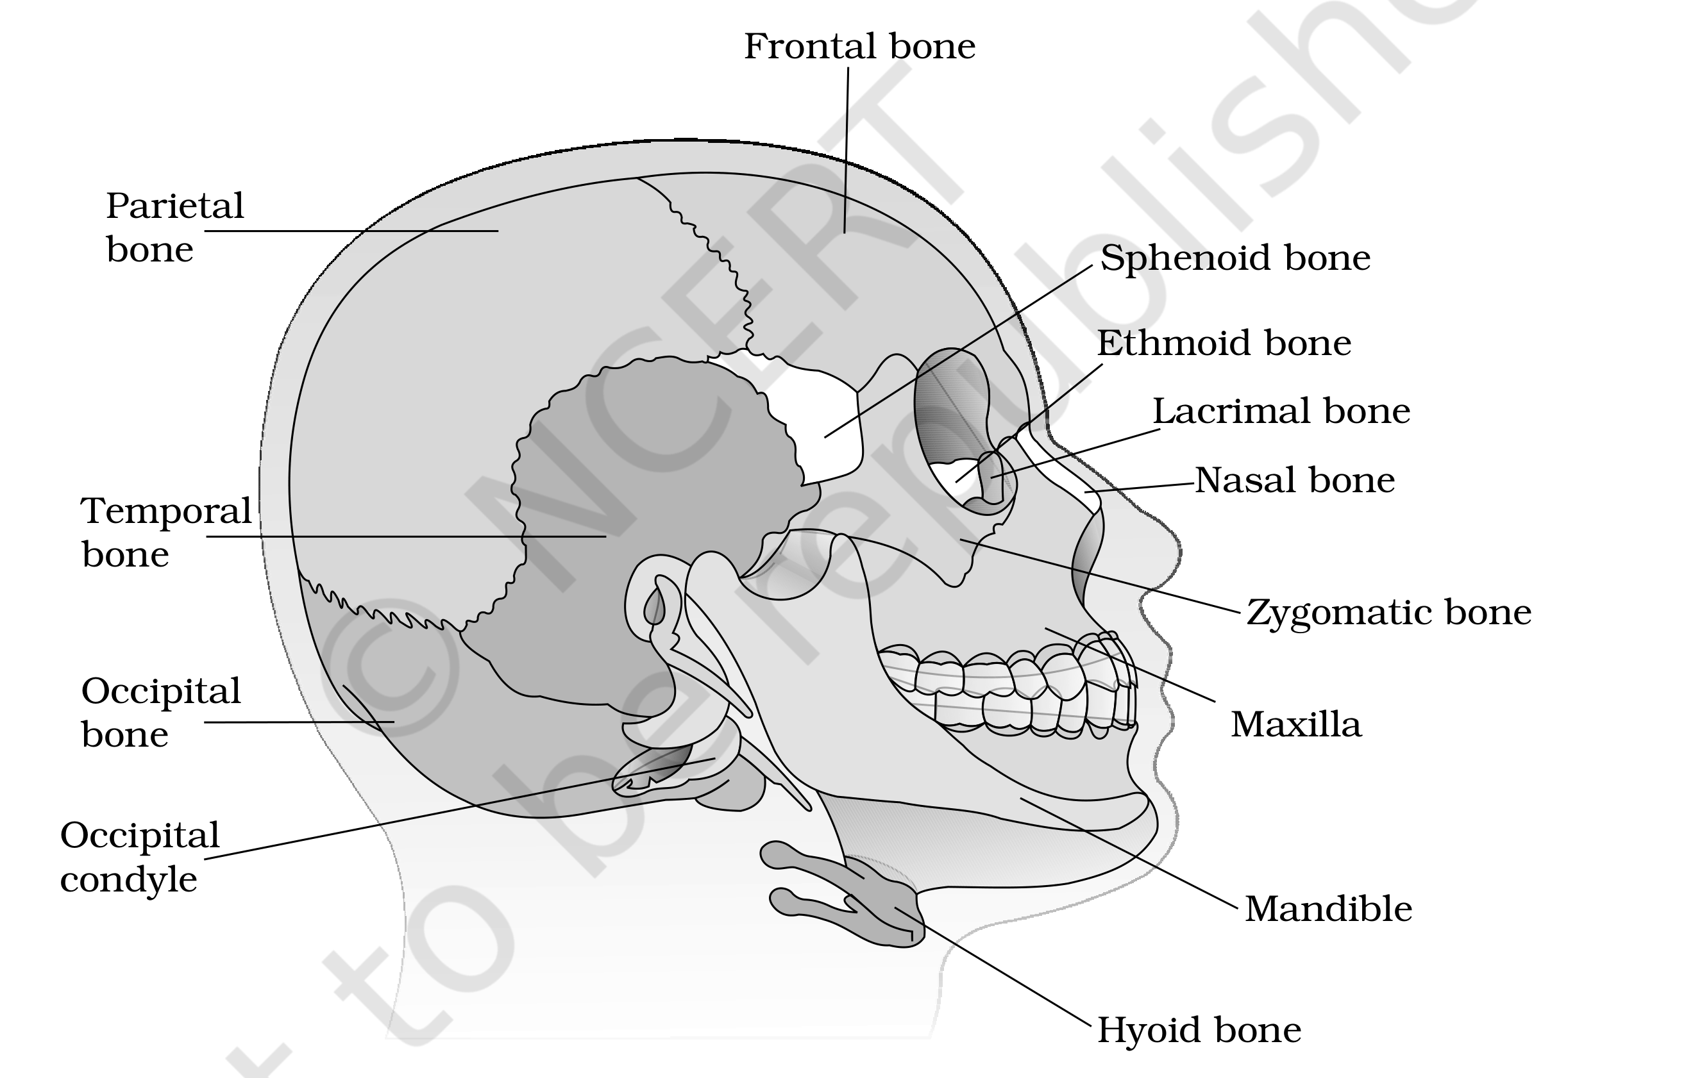
Figure 17.6 Diagrammatic view of human skull
Vertebral column (Figure 17.7) is formed by 26 serially arranged units called vertebrae and is dorsally placed. It extends from the base of the skull and constitutes the main framework of the trunk.
• Each vertebra has a central hollow portion (neural canal) through which the spinal cord passes. The first vertebra is the atlas, and it articulates with the occipital condyles.
• The column is differentiated into cervical (7), thoracic (12), lumbar (5), sacral (1-fused) and coccygeal (1-fused) regions, starting from the skull. The number of cervical vertebrae is seven in almost all mammals, including human beings. (Adjacent vertebrae are separated by an intervertebral disc of cartilage, which forms the cartilaginous joint discussed in 17.4.)
• The vertebral column protects the spinal cord, supports the head, and serves as the point of attachment for the ribs and the musculature of the back.
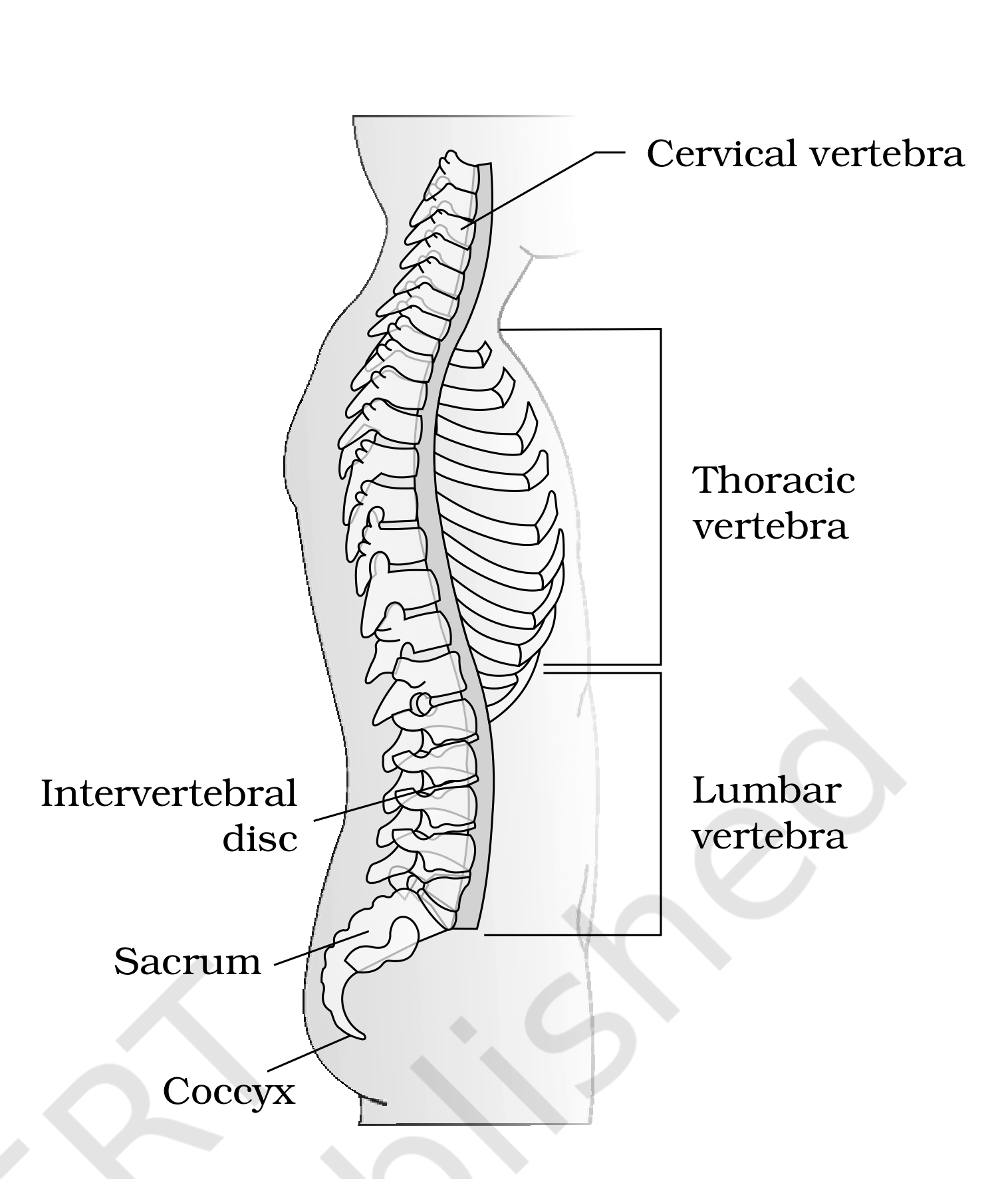
Figure 17.7 Vertebral column (right lateral view)
Sternum and ribs. The sternum is a flat bone on the ventral midline of the thorax. There are 12 pairs of ribs. Each rib is a thin flat bone connected dorsally to the vertebral column and ventrally to the sternum; it has two articulation surfaces on its dorsal end and is hence called bicephalic.
Rib set | Pairs | Attachment
True ribs | First 7 pairs | Dorsally attached to the thoracic vertebrae; ventrally connected to the sternum with hyaline cartilage
Vertebrochondral (false) ribs | 8th, 9th, 10th pairs | Do not articulate directly with the sternum; join the seventh rib with hyaline cartilage
Floating ribs | Last 2 pairs (11th, 12th) | Not connected ventrally

• Thoracic vertebrae, ribs and sternum together form the rib cage (Figure 17.8).
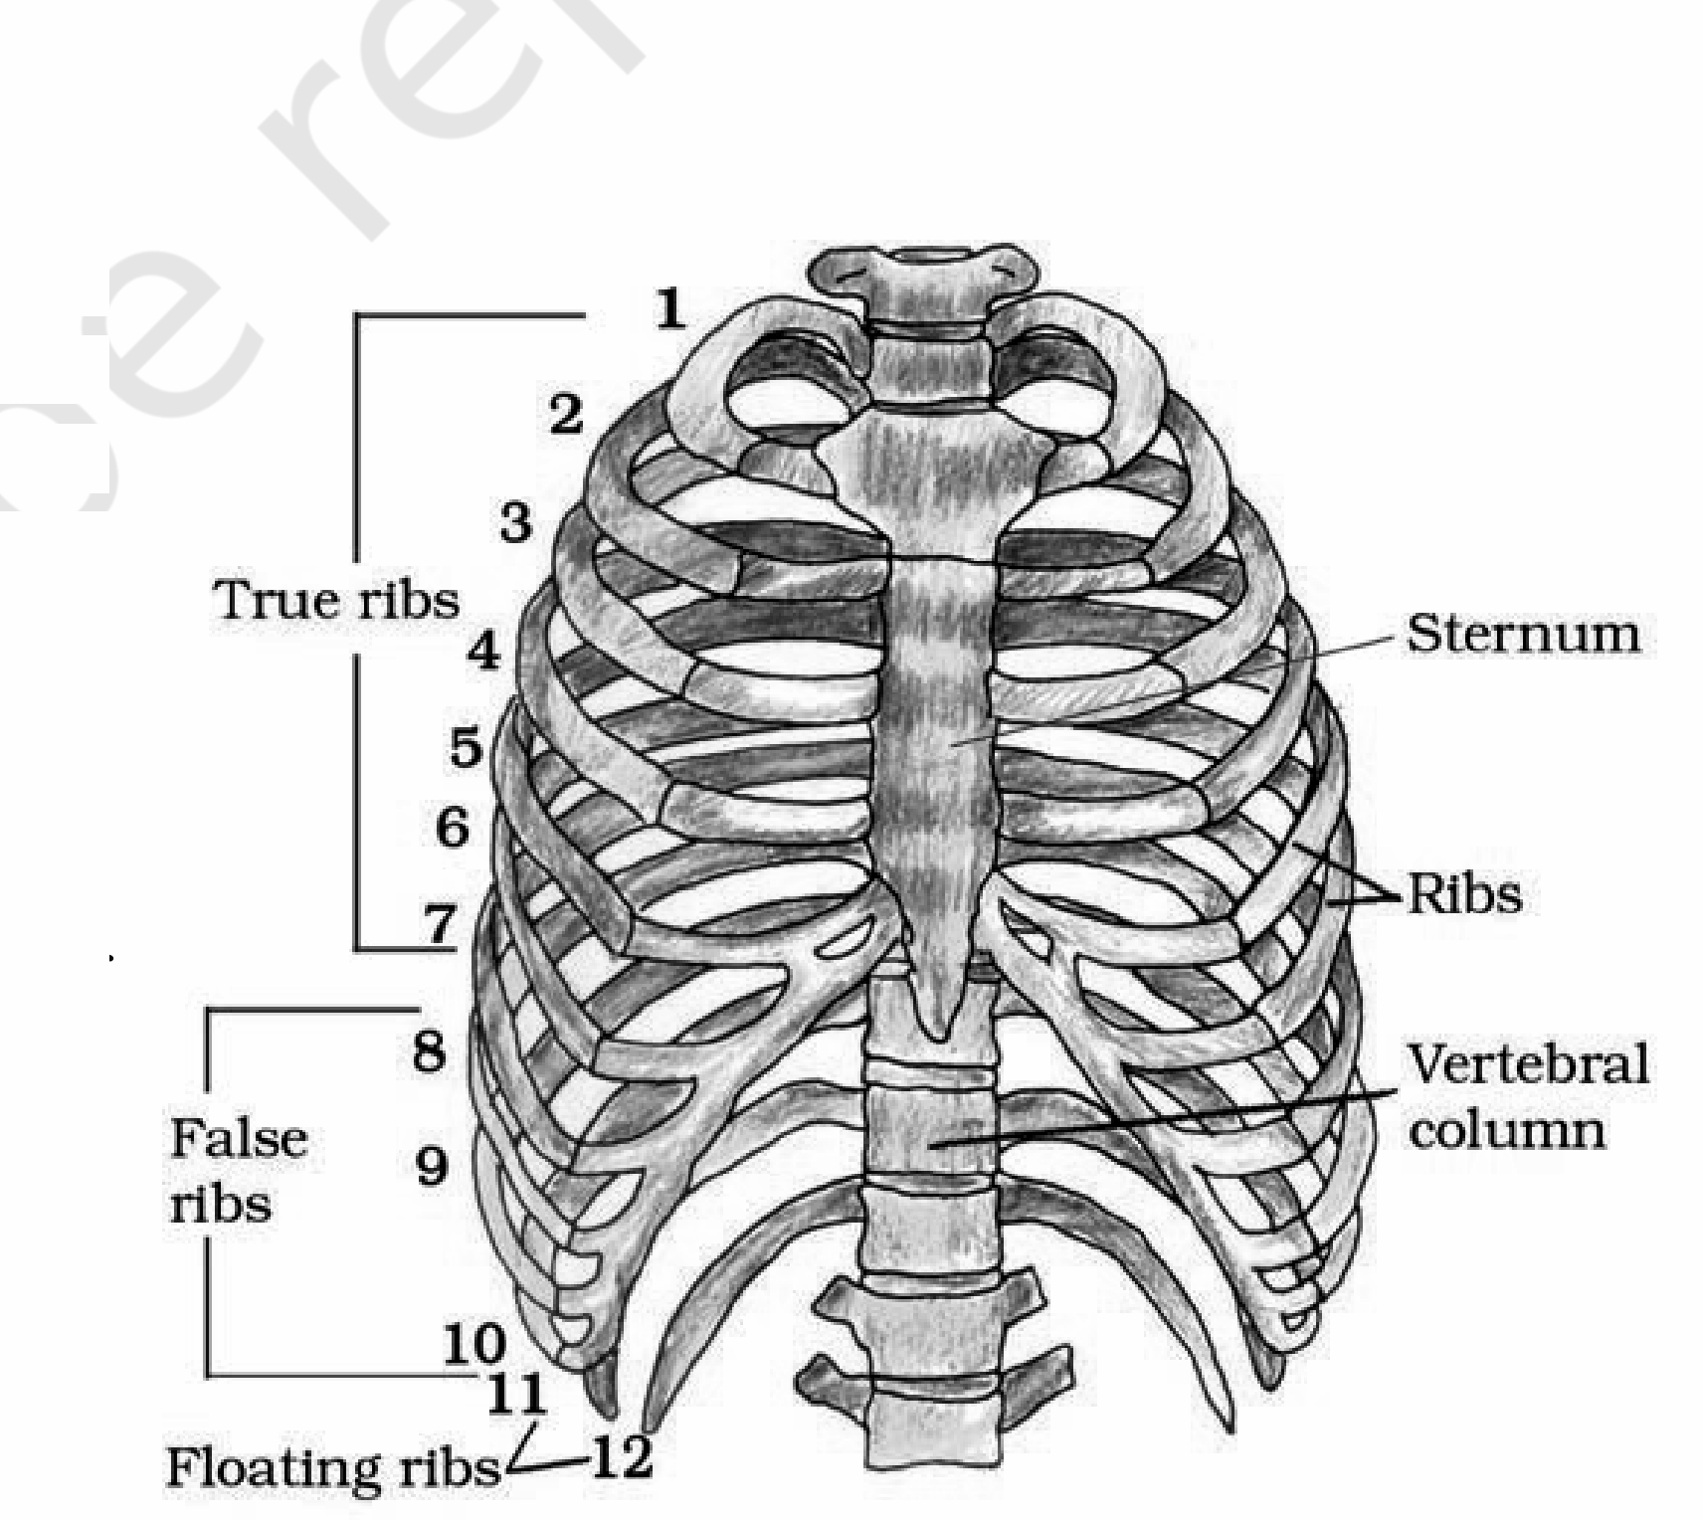
Figure 17.8 Ribs and rib cage
17.3.append | Appendicular Skeleton

• Appendicular skeleton - the bones of the limbs along with their girdles. Each limb is made of 30 bones.
Limb | Bones (with counts)
Hand / fore limb (Figure 17.9) | Humerus, radius and ulna, carpals (wrist bones - 8), metacarpals (palm bones - 5) and phalanges (digits - 14).
Leg / hind limb (Figure 17.10) | Femur (thigh bone - the longest bone), tibia and fibula, tarsals (ankle bones - 7), metatarsals (5) and phalanges (digits - 14).

• A cup-shaped bone called patella covers the knee ventrally (the knee cap).
• Pectoral and Pelvic girdle bones help in the articulation of the upper and lower limbs respectively with the axial skeleton. Each girdle is formed of two halves.
Pectoral girdle (Figure 17.9):
• Each half consists of a clavicle and a scapula.
• Scapula is a large triangular flat bone situated in the dorsal part of the thorax between the second and the seventh ribs. Its dorsal, flat, triangular body has a slightly elevated ridge called the spine, which projects as a flat, expanded process called the acromion; the clavicle articulates with this.
• Below the acromion is a depression called the glenoid cavity, which articulates with the head of the humerus to form the shoulder joint.
• Each clavicle is a long slender bone with two curvatures, commonly called the collar bone.
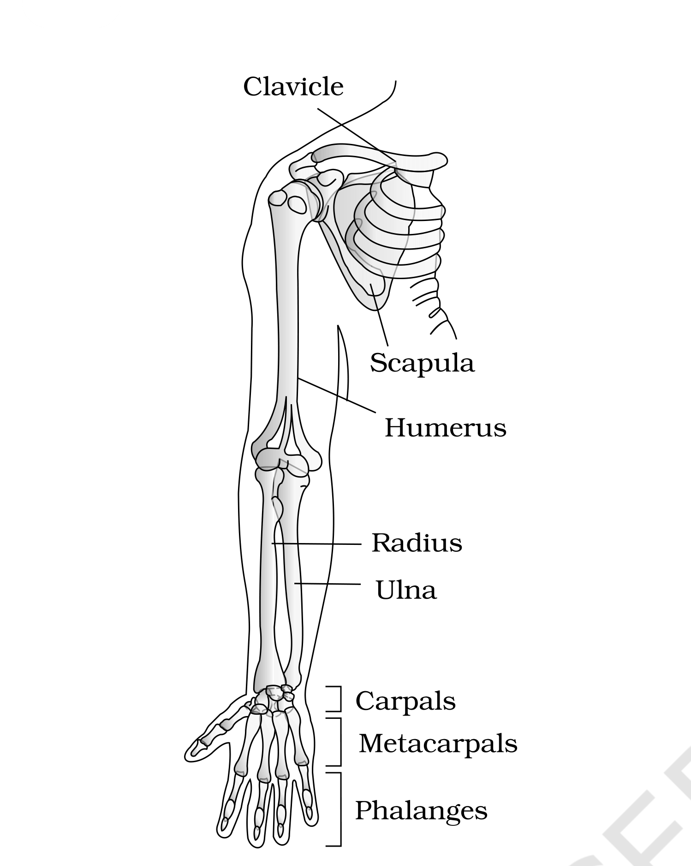
Figure 17.9 Right pectoral girdle and upper arm. (frontal view)
Pelvic girdle (Figure 17.10):
• Consists of two coxal bones. Each coxal bone is formed by the fusion of three bones - ilium, ischium and pubis.
• At the point of fusion is a cavity called the acetabulum, to which the thigh bone (femur) articulates.
• The two halves of the pelvic girdle meet ventrally to form the pubic symphysis, containing fibrous cartilage.
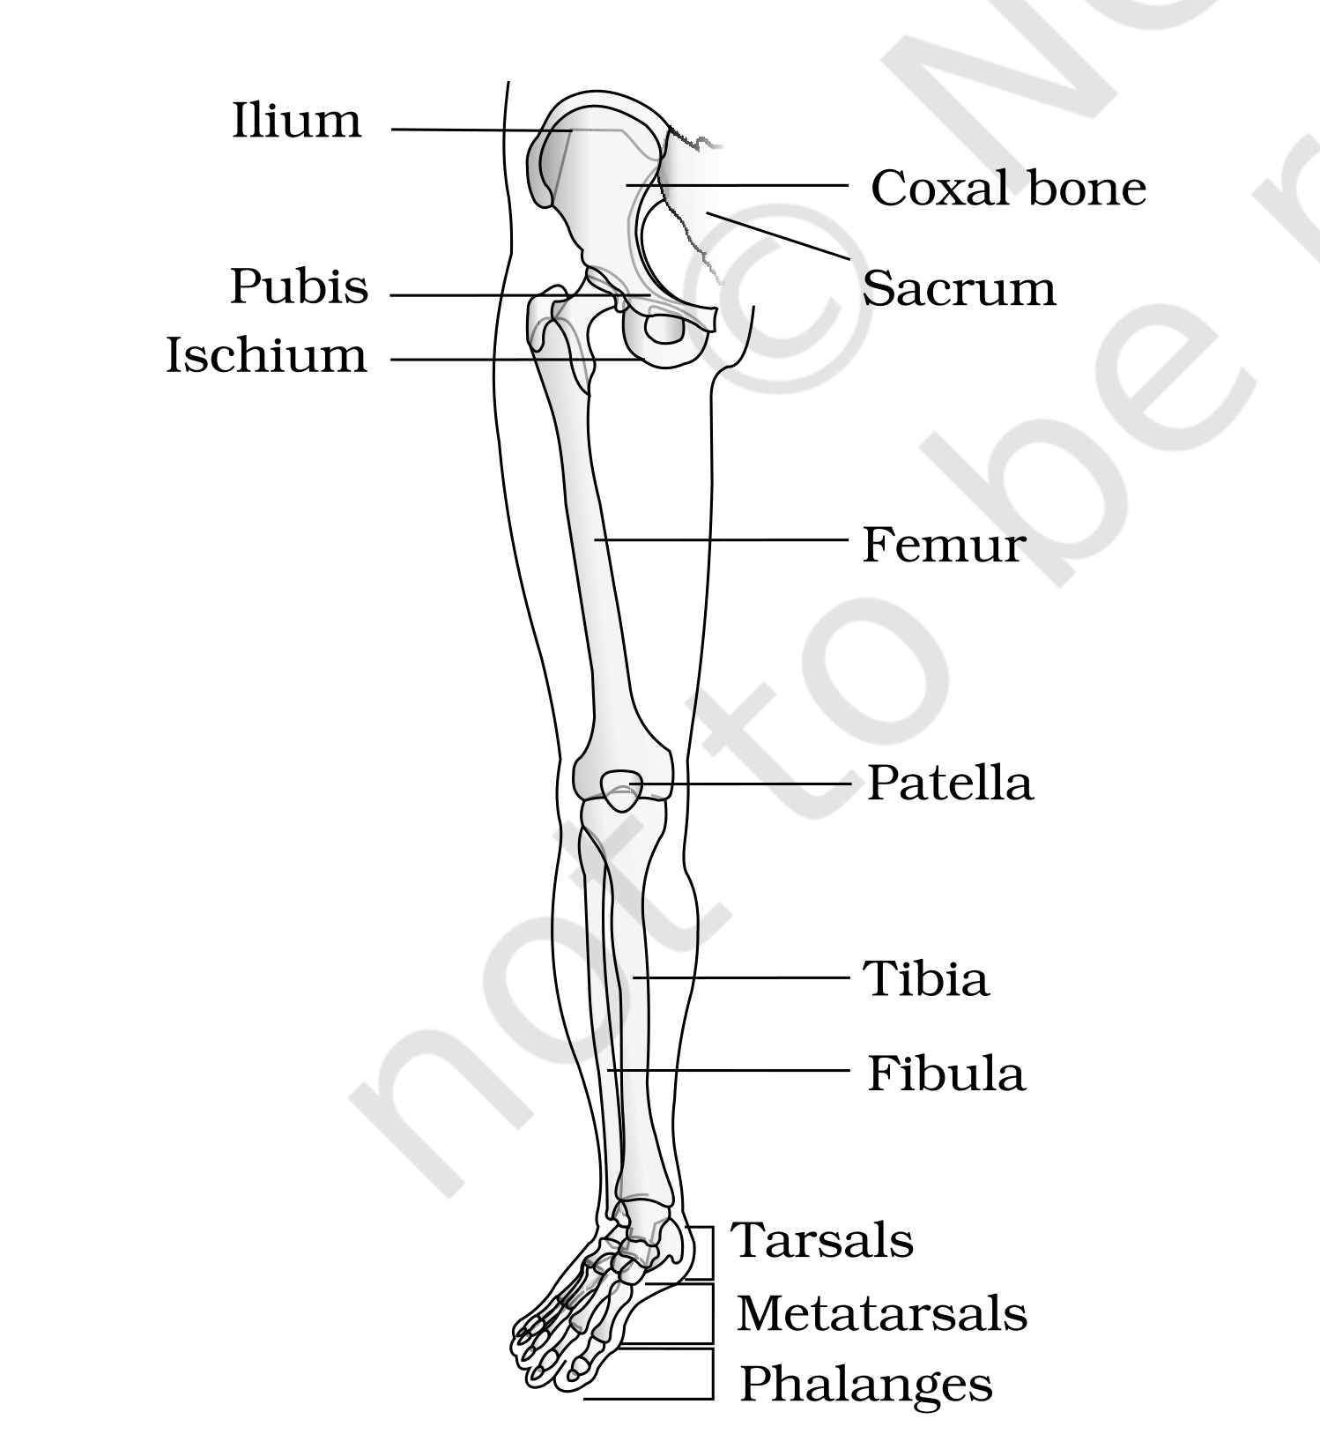
Figure 17.10 Right pelvic girdle and lower limb bones (frontal view)
[MEMORY AID - not in NCERT] Pectoral vs Pelvic girdle at a glance: pectoral = clavicle + scapula (articulates the arm at the glenoid cavity/shoulder); pelvic = one coxal bone per half = ilium + ischium + pubis fused (articulates the thigh at the acetabulum).

17.4 | Joints

Joints are essential for all types of movements involving the bony parts of the body; locomotory movements are no exception.
• Joints - points of contact between bones, or between bones and cartilages. The force generated by the muscles is used to carry out movement through joints, where the joint acts as a fulcrum. The movability at these joints varies depending on different factors.
Joints have been classified into three major structural forms, namely, fibrous, cartilaginous and synovial.
Joint type | Movement | Example
Fibrous | Do not allow any movement | Flat skull bones fusing end-to-end via dense fibrous connective tissue as sutures to form the cranium
Cartilaginous | Permit limited movements | Joint between adjacent vertebrae in the vertebral column
Synovial | Allow considerable movement; help in locomotion and many other movements | Characterised by a fluid-filled synovial cavity between the articulating surfaces of the two bones

Synovial joints are characterised by the presence of a fluid-filled synovial cavity between the articulating surfaces of the two bones. Such an arrangement allows considerable movement. Sub-types with examples:
• Ball and socket joint - between humerus and pectoral girdle.
• Hinge joint - knee joint.
• Pivot joint - between atlas and axis.
• Gliding joint - between the carpals.
• Saddle joint - between carpal and metacarpal of the thumb.
17.5 | Disorders of Muscular and Skeletal System

Disorder | Description
Myasthenia gravis | Auto immune disorder affecting the neuromuscular junction, leading to fatigue, weakening and paralysis of skeletal muscle.
Muscular dystrophy | Progressive degeneration of skeletal muscle, mostly due to a genetic disorder.
Tetany | Rapid spasms (wild contractions) in muscle due to low Ca⁺⁺ in body fluid.
Arthritis | Inflammation of joints.
Osteoporosis | Age-related disorder characterised by decreased bone mass and increased chances of fractures. Decreased levels of estrogen is a common cause.
Gout | Inflammation of joints due to the accumulation of uric acid crystals.

[NOTE] Chapter map recap: movement (amoeboid / ciliary / muscular) leads to muscle (skeletal / visceral / cardiac), whose contractile unit is the sarcomere; contraction runs by the sliding filament theory; muscles act on the skeletal system (206 bones: axial + appendicular) through joints. Disorders can strike either the muscular side (myasthenia gravis, muscular dystrophy, tetany) or the skeletal/joint side (arthritis, osteoporosis, gout).

S | SUMMARY

Movement is an essential feature of all living beings. Protoplasmic streaming, ciliary movements, and the movements of fins, limbs, wings, etc., are some of the forms exhibited by animals. A voluntary movement that causes the animal to change its place is locomotion. Animals move generally in search of food, shelter, mate, breeding ground, better climate, or to protect themselves.
The cells of the human body exhibit amoeboid, ciliary and muscular movements. Locomotion and many other movements require coordinated muscular activity. Three types of muscles are present in our body: skeletal muscles are attached to skeletal elements and are striated and voluntary; visceral muscles, in the inner walls of visceral organs, are nonstriated and involuntary; cardiac muscles, the muscles of the heart, are striated, branched and involuntary. Muscles possess excitability, contractility, extensibility and elasticity, and contribute 40-50 per cent of an adult's body weight.
The muscle fibre is the anatomical unit of muscle; each fibre holds many parallelly arranged myofibrils, and each myofibril many serially arranged sarcomeres, which are the functional units. Each sarcomere has a central 'A' band of thick myosin filaments and two half 'I' bands of thin actin filaments on either side, marked by 'Z' lines; the 'H' zone is the part of the thick filament not overlapped by thin filaments. Actin and myosin are polymerised proteins with contractility. On a resting actin filament the active sites for myosin are masked by troponin. The myosin head contains ATPase and carries ATP binding sites and active sites for actin.
A motor neuron carries the signal to the muscle fibre, generating an action potential in it; this releases Ca⁺⁺ from the sarcoplasmic reticulum. Ca⁺⁺ activates actin, which binds the myosin head to form a cross bridge. The cross bridges pull the actin filaments, sliding them over the myosin filaments - i.e. contraction, in which the 'I' bands shorten while the 'A' bands keep their length. Ca⁺⁺ is then returned to the sarcoplasmic reticulum, actin is inactivated, the cross bridges are broken and the muscle relaxes. Repeated stimulation leads to fatigue (lactic acid from anaerobic glycogen breakdown). Muscles are classified as Red and White fibres based primarily on the amount of the red-coloured myoglobin pigment in them.
Bones and cartilages constitute our skeletal system (206 bones), divisible into axial and appendicular. Skull, vertebral column, ribs and sternum constitute the axial skeleton (80 bones); limb bones and girdles form the appendicular skeleton (30 bones per limb). Three types of joints are formed between bones, or between bone and cartilage - fibrous, cartilaginous and synovial. Synovial joints allow considerable movement and therefore play a significant role in locomotion. Disorders may strike the muscular side (myasthenia gravis, muscular dystrophy, tetany) or the skeletal/joint side (arthritis, osteoporosis, gout).
E | EXERCISES

[NOTE] All ten NCERT exercises are reproduced below with worked answers. Every answer is sourced from the chapter text above. Where NCERT never states the answer outright but it follows from a definition the chapter does give (Exercise 9c, 9d), that is flagged in place.

1. Draw the diagram of a sarcomere of skeletal muscle showing different regions.
Answer. Redraw Figure 17.2(b) above and label: the two bounding 'Z' lines; the central 'A' band (dark, anisotropic, thick myosin filaments) with the 'M' line in its middle and the 'H' zone at its centre (thick filaments only); and the 'I' bands (light, isotropic, thin actin filaments) on either side, each Z line bisecting an 'I' band. One sarcomere = the portion between two successive 'Z' lines = one whole 'A' band plus two half 'I' bands.
2. Define sliding filament theory of muscle contraction.
Answer. The mechanism of muscle contraction is best explained by the sliding filament theory, which states that contraction of a muscle fibre takes place by the sliding of the thin filaments over the thick filaments.
3. Describe the important steps in muscle contraction.
• A signal from the CNS travels via a motor neuron to the neuromuscular junction, releasing Acetyl choline, which generates an action potential in the sarcolemma.
• The action potential spreads through the fibre and releases Ca⁺⁺ into the sarcoplasm; calcium binds a subunit of troponin, removing the masking of the active sites for myosin.
• Using ATP hydrolysis, the myosin head binds the exposed active sites on actin to form a cross bridge, which pulls the actin filaments towards the centre of the 'A' band; the 'Z' lines are pulled inwards and the sarcomere shortens ('I' bands reduce, 'A' bands keep their length).
• The head releases ADP and P_{i}, a new ATP binds, the cross bridge is broken, the ATP is hydrolysed again and the cycle repeats, causing further sliding.
• Contraction continues till Ca⁺⁺ is pumped back into the sarcoplasmic cisternae, the actin filaments are masked again and the 'Z' lines return to their original position - relaxation.
4. Write true or false. If false change the statement so that it is true.
• (a) Actin is present in thin filament - TRUE. The light 'I' band contains actin, and actin filaments are thinner than myosin filaments, hence thin filaments.
• (b) H-zone of striated muscle fibre represents both thick and thin filaments - FALSE. Corrected: the 'H' zone represents only the thick (myosin) filaments - it is the central part of the thick filament not overlapped by thin filaments.
• (c) Human skeleton has 206 bones - TRUE. In human beings the skeletal system is made of 206 bones and a few cartilages.
• (d) There are 11 pairs of ribs in man - FALSE. Corrected: there are 12 pairs of ribs (7 true + 3 vertebrochondral/false + 2 floating).
• (e) Sternum is present on the ventral side of the body - TRUE. The sternum is a flat bone on the ventral midline of the thorax.
5. Write the difference between:
(a) Actin and Myosin
Feature | Actin | Myosin
Filament | Thin filament | Thick filament
Band | Light 'I' (isotropic) band | Dark 'A' (anisotropic) band
Build-up | Two 'F' (filamentous) actins helically wound; each 'F' actin a polymer of 'G' (globular) actins | Polymerised protein of many meromyosin monomers (HMM head + short arm, LMM tail)
Associated proteins | Tropomyosin along its length and troponin at regular intervals, which masks the myosin-binding sites at rest | None; the globular head itself is an active ATPase enzyme with ATP binding sites and active sites for actin
Role in contraction | Slides over the thick filament and is pulled inwards | Forms the cross bridge / cross arm that pulls the actin

(b) Red and White muscles
• Red fibres: high myoglobin (reddish appearance), plenty of mitochondria, lower sarcoplasmic reticulum, use stored oxygen for ATP - aerobic muscles.
• White fibres: very little myoglobin (pale/whitish), few mitochondria, high sarcoplasmic reticulum, depend on the anaerobic process for energy.
(c) Pectoral and Pelvic girdle
• Pectoral girdle: each half = a clavicle (collar bone, two curvatures) + a scapula (triangular flat bone between the second and seventh ribs, bearing the spine and acromion). Its glenoid cavity receives the head of the humerus to form the shoulder joint, articulating the upper limb.
• Pelvic girdle: two coxal bones, each formed by the fusion of ilium, ischium and pubis. The acetabulum at the point of fusion receives the femur, articulating the lower limb; the two halves meet ventrally at the pubic symphysis (fibrous cartilage).
6. Match Column I with Column II:
Column I | Column II | Why
(a) Smooth muscle | (iv) Involuntary | Visceral/smooth muscle is not under voluntary control of the nervous system
(b) Tropomyosin | (ii) Thin filament | Two tropomyosin filaments run close to the 'F' actins of the thin filament
(c) Red muscle | (i) Myoglobin | Red fibres carry a high content of the red oxygen-storing pigment myoglobin
(d) Skull | (iii) Sutures | Flat skull bones fuse end-to-end as fibrous joints called sutures to form the cranium

7. What are the different types of movements exhibited by the cells of human body?
Answer. Three main types: amoeboid (macrophages and leucocytes, by pseudopodia and microfilaments), ciliary (ciliated epithelium of internal tubular organs - trachea, female reproductive tract) and muscular (limbs, jaws, tongue, using the contractile property of muscles).
8. How do you distinguish between a skeletal muscle and a cardiac muscle?
Feature | Skeletal muscle | Cardiac muscle
Location | Closely associated with the skeletal components of the body | Muscles of the heart
Arrangement | Bundles of parallel fibres (fascicles) held by fascia | Many cells assemble in a branching pattern
Appearance | Striated (striped under the microscope) | Striated
Regulation | Voluntary - under nervous control | Involuntary - the nervous system does not control it directly
Chief role | Locomotory actions and changes of body posture | Contraction of the heart

9. Name the type of joint between the following:
• (a) atlas/axis - pivot joint.
• (b) carpal/metacarpal of thumb - saddle joint.
• (c) between phalanges - hinge joint. (Applied answer: NCERT lists the hinge joint only as the knee joint; the phalangeal joints allow the same single-plane movement.)
• (d) femur/acetabulum - ball and socket joint. (Applied answer: NCERT gives the humerus/pectoral-girdle joint as its ball-and-socket example and states that the thigh bone articulates into the cup-like acetabulum.)
• (e) between cranial bones - fibrous joint (immovable sutures).
• (f) between pubic bones in the pelvic girdle - cartilaginous joint - the pubic symphysis, which contains fibrous cartilage.
10. Fill in the blank spaces:
• (a) All mammals (except a few) have seven (7) cervical vertebrae.
• (b) The number of phalanges in each limb of human is 14.
• (c) Thin filament of myofibril contains 2 'F' actins and two other proteins, namely tropomyosin and troponin.
• (d) In a muscle fibre Ca⁺⁺ is stored in the sarcoplasmic reticulum.
• (e) 11th and 12th pairs of ribs are called floating ribs.
• (f) The human cranium is made of 8 bones.

